Finite Element Analysis: Thermal Diffusion

In order to find the ideal ramp time, I compared the gradient graphs of heat diffusion using both FORTRAN (alternating direction implicit) and COMSOL. The criteria for finding the ideal ramp time is how fast we can heat the bubble detector without the maximum gradient exceeding 1 degree. The first graph below shows the ramp time comparison for the FORTRAN simulation while the second graph shows the same analysis using COMSOL. Multiple temperature slopes (15.0°C/Hours) were sampled in FORTRAN and COMSOL using a DO loop and a parametric sweep respectively.

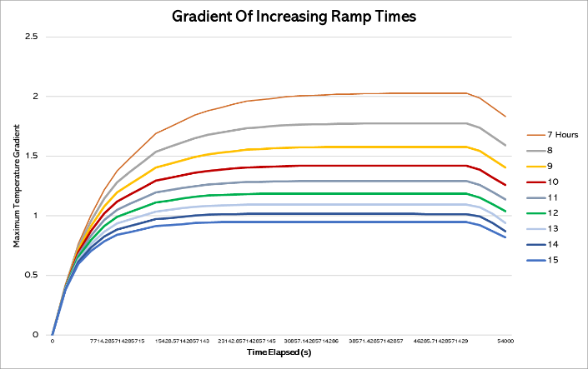

As the graphs show, the ideal ramp time for COMSOL is approximately 15 hours while it is approximately 10 hours for FORTRAN. The graph of the 10 hour FORTRAN simulation was plotted to confirm that the gradient does indeed remain below 1.

On the other end of the spectrum, I plotted the 1 hour ramping speed results for both simulations.

The fast ramp graph provides further evidence that COMSOL simulates diffusion as a slower process than FORTRAN does. This is likely a result of our simplfication of the system in FORTRAN to a 9x9 matrix while COMSOL likely computes a much finer mesh thus slowing diffusion.

In order to compare the effects of the chosen time increment and lattice size of both simulations. As shown below, for dt = 135.0s and dx=dy=1.0cm in the FORTRAN simulation the Courant-Friederichs-Lewy condition is not met and thus divergence is obsevered (orange data points in the plot). Other than the divergent simulation, the coarseness of the simulation lattice appears to have a negligible effect on these results. Perhaps the lattice dependence is more pronounced for geometries of increasing complexity.

The plot below shows the results for the three-dimensional rectangular box bubble chamber simulation using the same range of hours test in the two-dimensional COMSOL simulation. As expected, due to the addition of a third dimension, heat takes much longer to diffuse through the entire model thus calling for a faster ramp speed than the two-dimensional case.

Above is a plot of the three domain probes of the 3D COMSOL model (Max, Avg, Min) and an image of the model’s vertical cross-sections. Below is an application of the same simulation followed by the simulation and performance coefficient plot of a thermoelectric cooler.

